**LAPORAN**

“MySQL”



OLEH :

Nama :

[Mochammad Rizal Al Anshori](https://mis.eepis-its.edu/unit/bak/mahasiswa.php?Status=A&Program=4&Jurusan=9&Kelas=3&AB=A&Detil=AAAHv9AALAABIpCAAH" \t "https://mis.eepis-its.edu/unit/bak/_blank) (4210141008)

M. Eryan Wicaksono (4210151004)

[Mohammad Yusuf Prastomo](https://mis.eepis-its.edu/unit/bak/mahasiswa.php?Status=A&Program=4&Jurusan=9&Kelas=3&AB=A&Detil=AAAHv9AALAABorAAAA" \t "https://mis.eepis-its.edu/unit/bak/_blank) (4210151012)

**PRORAM STUDI TEKNOLOGI GAME**

**DEPARTEMEN TEKNOLOGI MULTIMEDIA KREATIF**

**POLITEKNIK ELEKTRONIKA NEGERI SURABAYA**

**2018/2019**

**Insert**

- Insert Post :

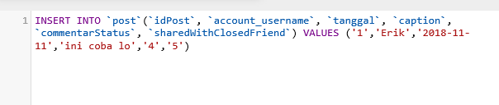

*INSERT INTO `post`(`idPost`, `account_username`, `tanggal`, `caption`, `commentarStatus`, `sharedWithClosedFriend`) VALUES ('1','Erik','2018-11-11','ini coba lo','4','5)*

Berikut Hasilnya :

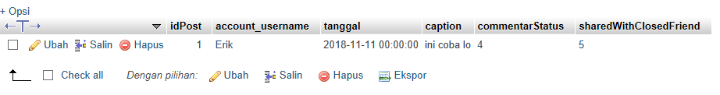

- Insert New Account :

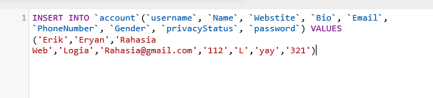

*INSERT INTO `account`(`username`, `Name`, `Webstite`, `Bio`, `Email`, `PhoneNumber`, `Gender`, `privacyStatus`, `password`) VALUES ('Erik','Eryan','Rahasia [Web','Logia','Rahasia@gmail.com','112','L','yay','321')](mailto:Web','Logia','Rahasia@gmail.com','112','L','yay','321'))*

Berikut Hasilnya :

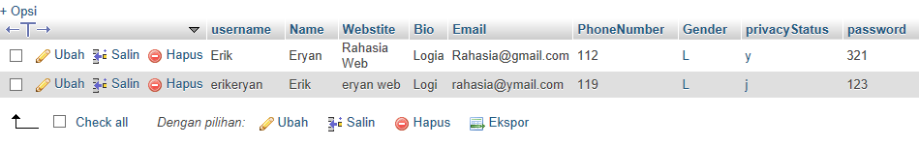

- Insert Send Commend :

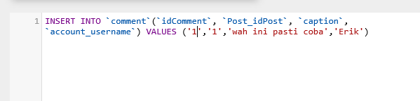

*INSERT INTO `comment`(`idComment`, `Post_idPost`, `caption`, `account_username`) VALUES ('1','1','wah ini pasti coba','Erik')*

Berikut Hasilnya :

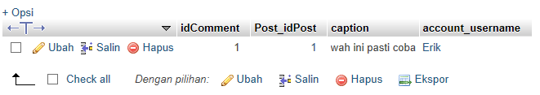

- Insert Like :

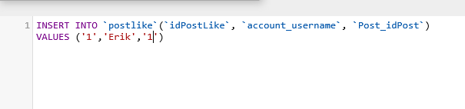

*INSERT INTO `postlike`(`idPostLike`, `account_username`, `Post_idPost`) VALUES ('1','Erik','1')*

Berikut Hasilnya :

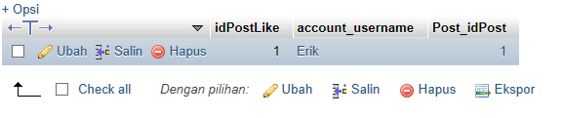

- Insert Story :

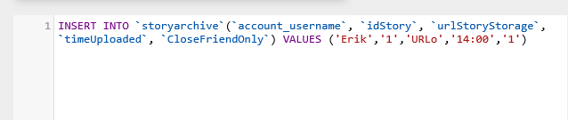

*INSERT INTO `storyarchive`(`account_username`, `idStory`, `urlStoryStorage`, `timeUploaded`, `CloseFriendOnly`) VALUES ('Erik','1','URLo','14:00','1')*

Berikut Hasilnya :

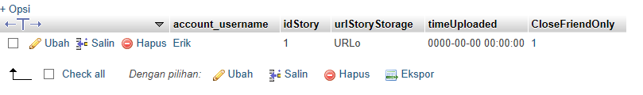

Insert Follow dan Close Friend :

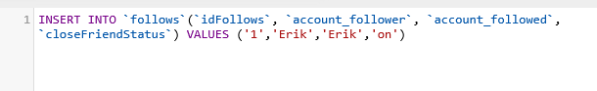

*INSERT INTO `follows`(`idFollows`, `account_follower`, `account_followed`, `closeFriendStatus`) VALUES ('1','Erik','Erik','on')*

Berikut Hasilnya

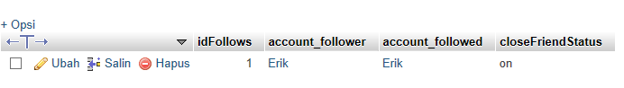

**Update**

**-** Update Post :

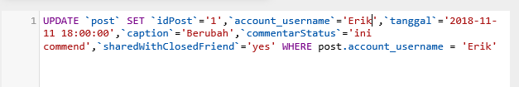

*UPDATE `post` SET `idPost`='1',`account_username`='Erik',`tanggal`='2018-11-11 18:00:00',`caption`='Berubah',`commentarStatus`='ini commend',`sharedWithClosedFriend`='yes' WHERE post.account_username = 'Erik'*

Berikut Hasilnya :



- Update Account :

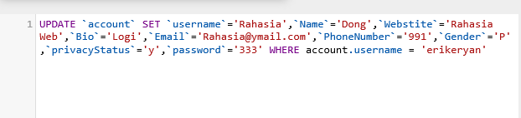

*UPDATE `account` SET `username`='Rahasia',`Name`='Dong',`Webstite`='Rahasia Web',`Bio`='Logi',`Email`='Rahasia@ymail.com',`PhoneNumber`='991',`Gender`='P',`privacyStatus`='hai',`password`='333' WHERE account.username = 'erikeryan'*

Berikut Hasilnya :

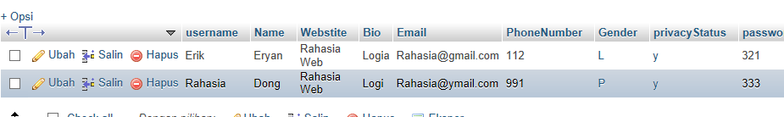

- Update Comment

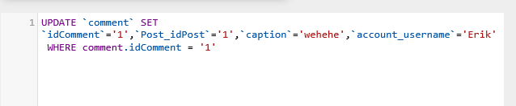

*UPDATE `comment` SET `idComment`='1',`Post_idPost`='1',`caption`='wehehe',`account_username`='Erik' WHERE comment.idComment = '1'*

Berikut Hasilnya :

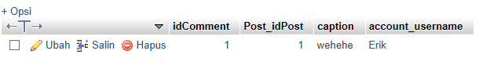

**Delete**

-Delete Post :

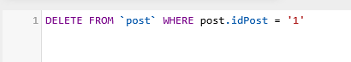

*DELETE FROM `post` WHERE post.idPost = '1'*

*-* Delete Account :

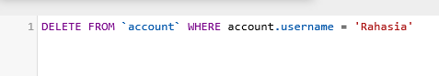

*DELETE FROM `account` WHERE account.username = 'Rahasia'*

- Delete Commend :

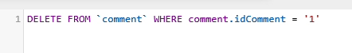

*DELETE FROM `comment` WHERE comment.idComment = '1'*

- Delete like (unlike)

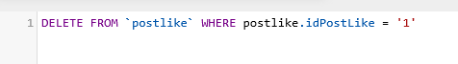

*DELETE FROM `postlike` WHERE postlike.idPostLike = '1'*

- Delete Story

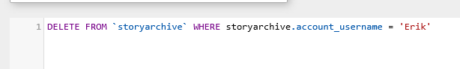

*DELETE FROM `storyarchive` WHERE storyarchive.account_username = 'Erik'*

- Delete follow (unfollow) dan close friend

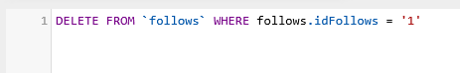

*DELETE FROM `follows` WHERE follows.idFollows = '1'*